View & Edit Sites Details

[Echoes - Land Management](https://echoes-platform.eu/app/main/map-view)

16 Steps

Go to <https://echoes-platform.eu/app/main/sites/my-sites>

1 - Find the Site you want to view or edit

Find the site you want to view, either by using the search bar or by scrolling through the list in the data table.

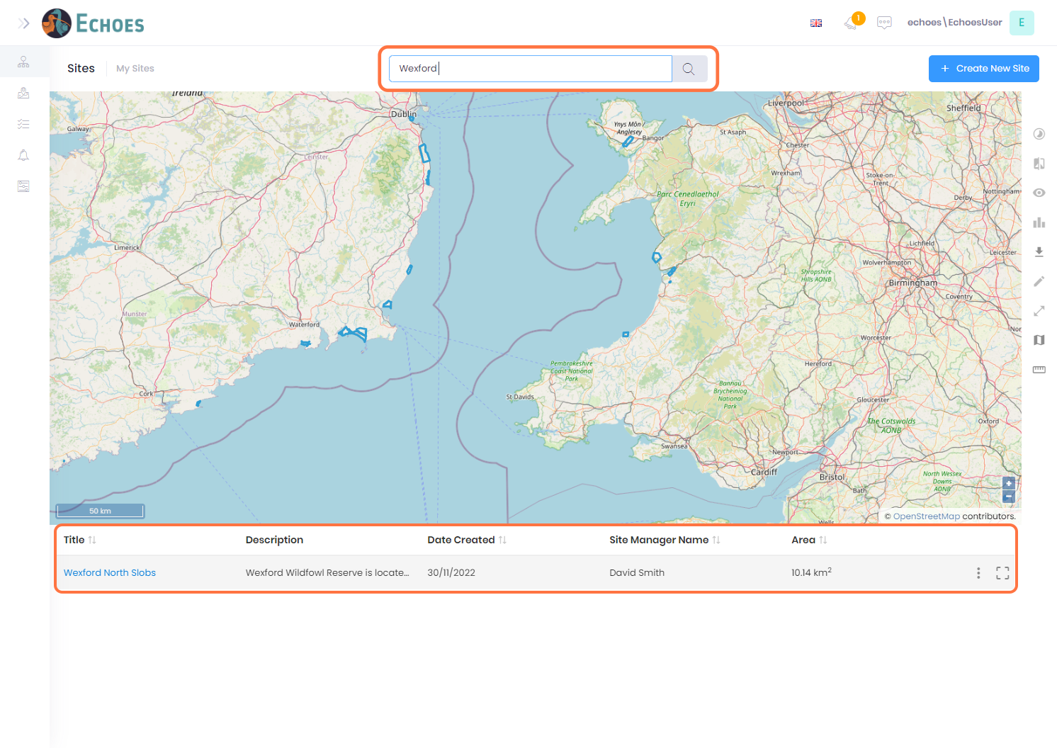

2 - Viewing your site (1/2)

* First way to view your site is by clicking on the name of the site you want to view.

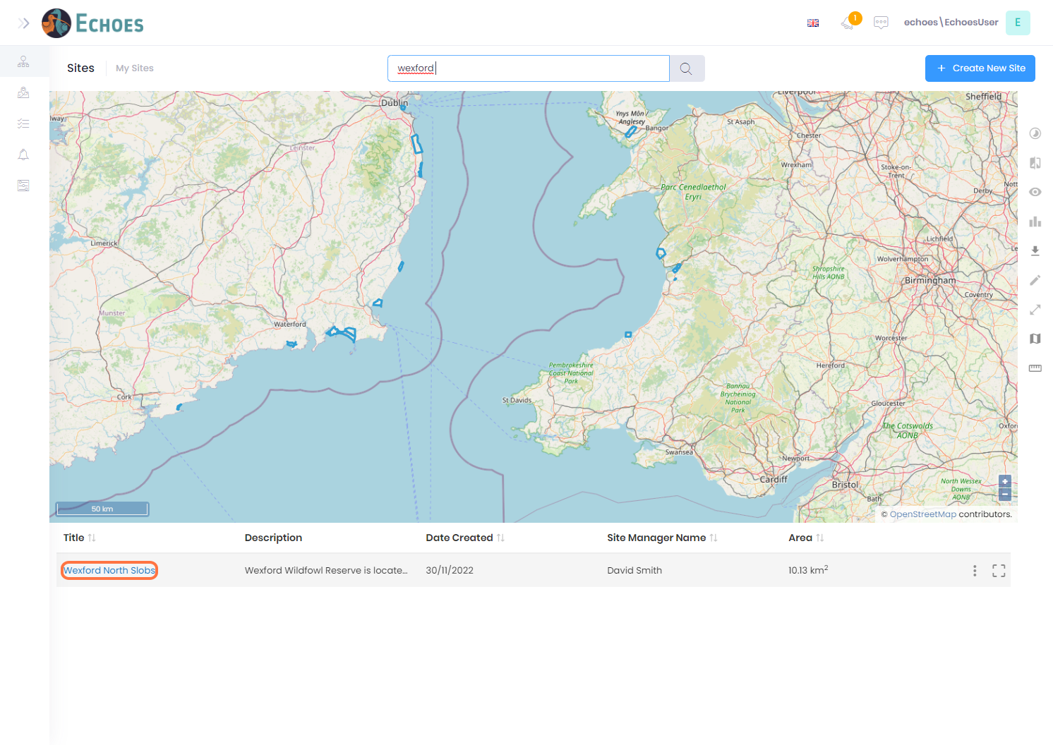

3 - Viewing your site (2/2)

* First way to view your site is by clicking the ellipses icon, then the Details option from the list.

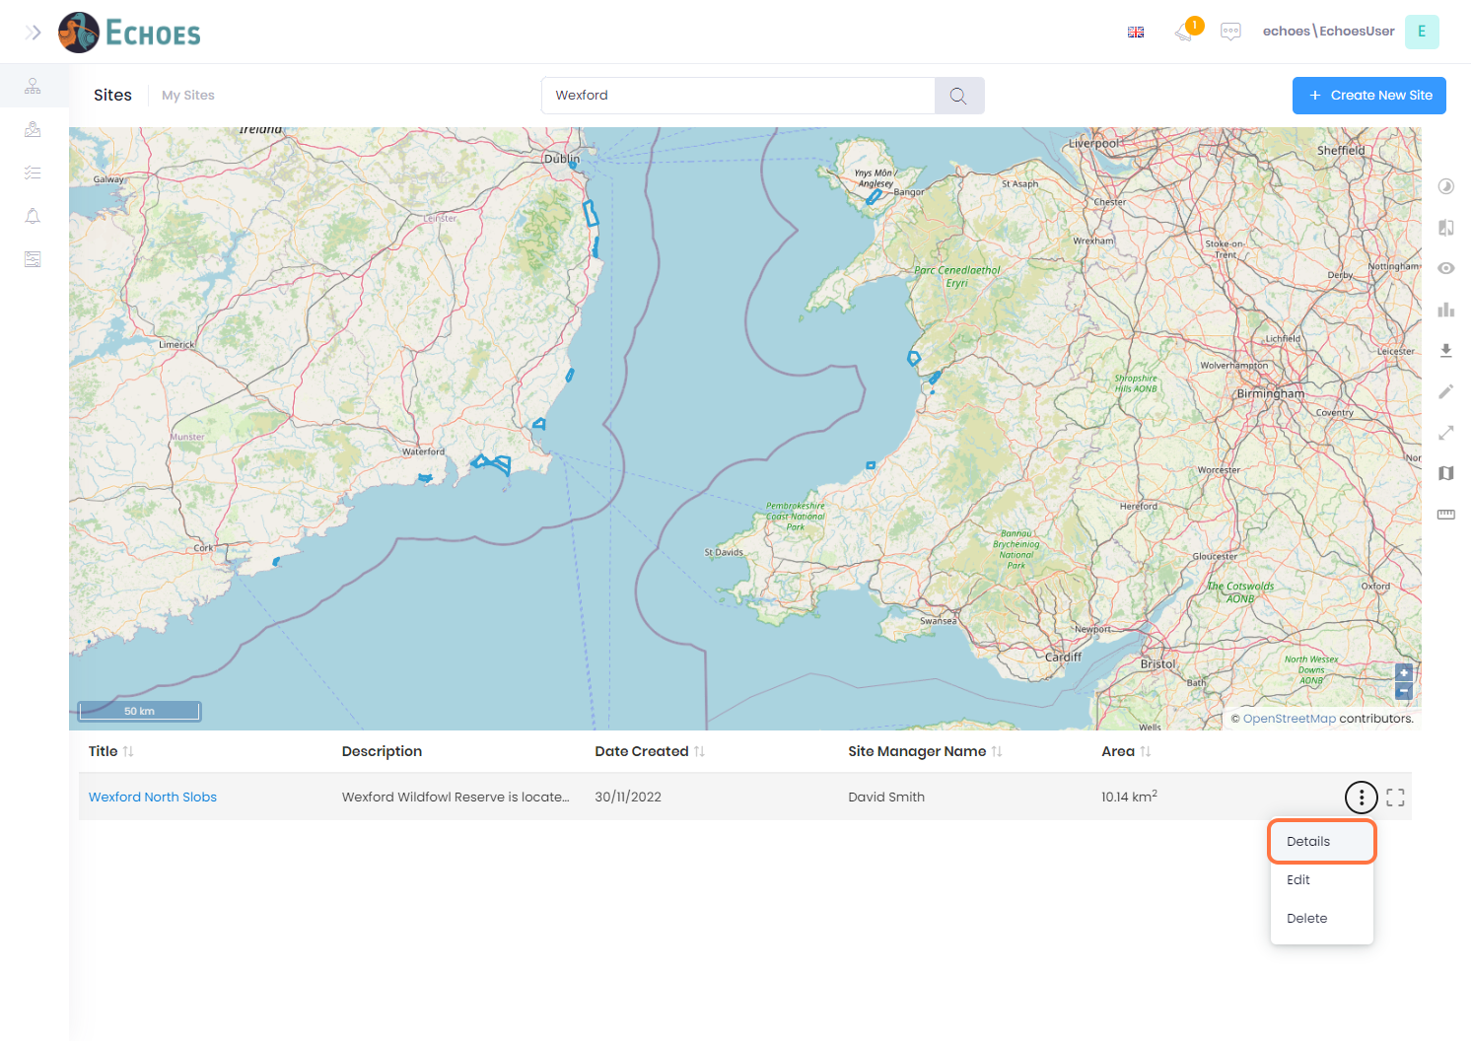

4 - Site Details page

You will now be presented with the sites details page. An overview of each section can be seen in the next 7 steps.

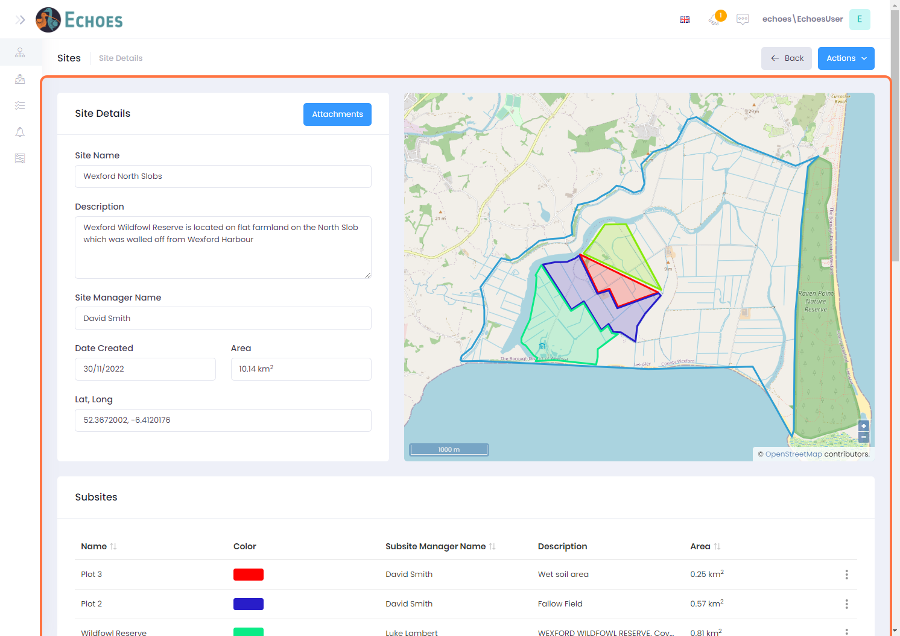

5 - Site Details Overview (1/7)

Overview of the sites details are here.

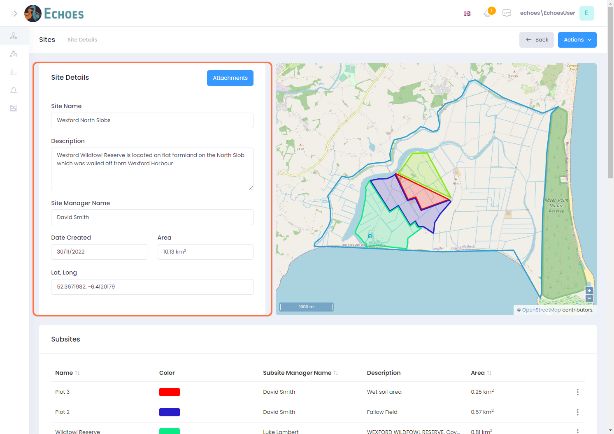

6 - Site Details Overview (2/7)

A map view of the sites boundary, as well as any sub sites associated to that site.

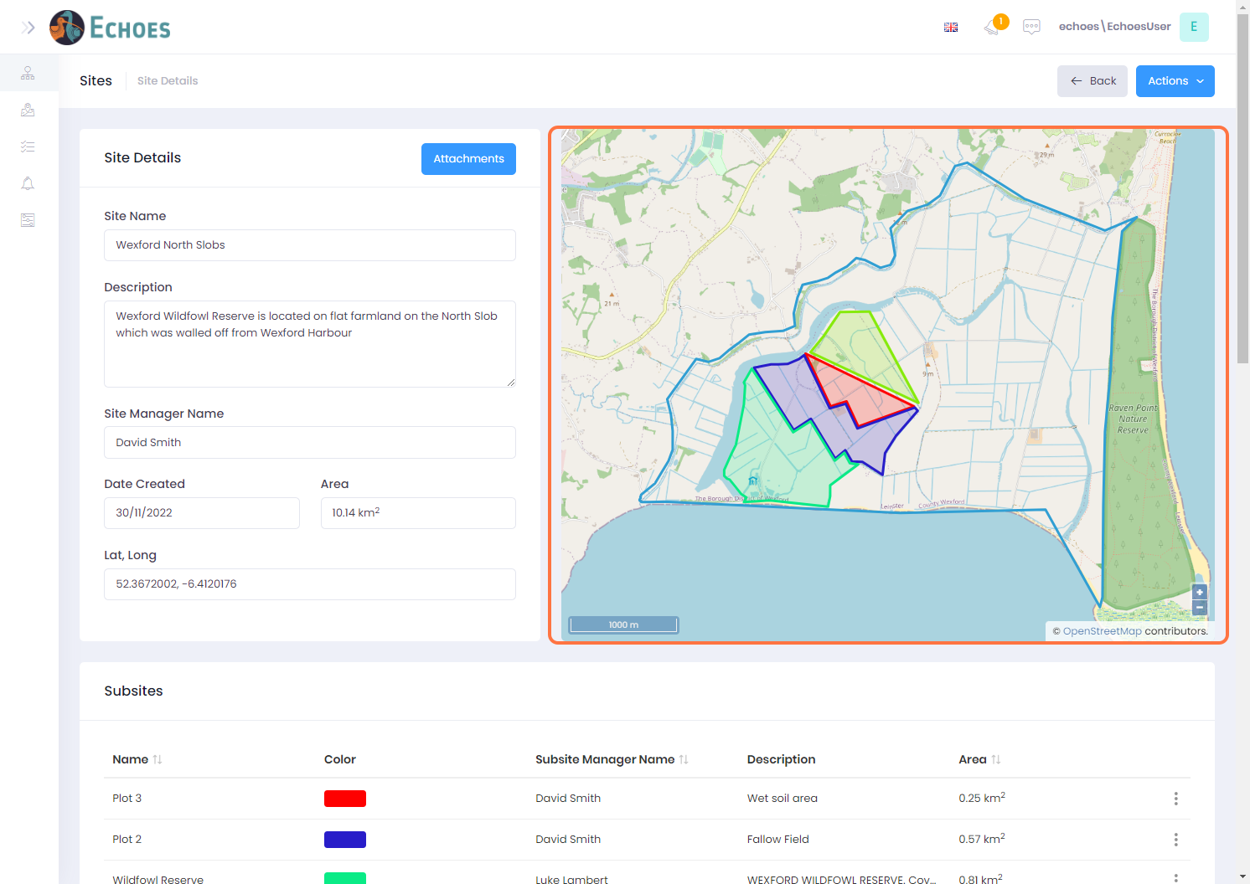

7 - Site Details Overview (3/7)

A list of the sub sites within this site can be viewed in a data table below.

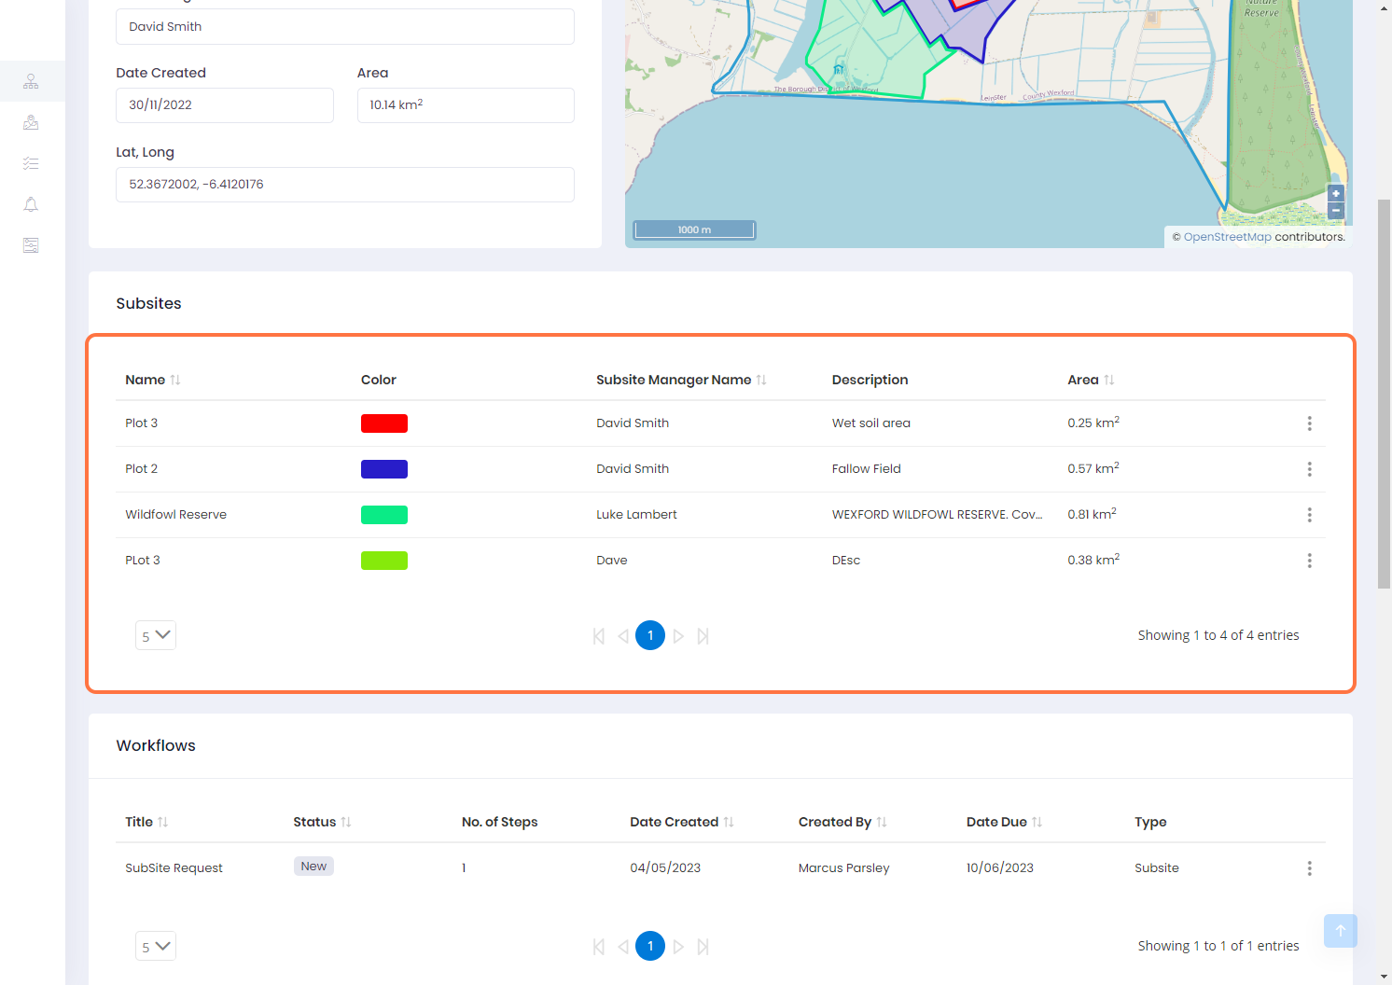

8 - Site Details Overview (4/7)

Any workflows associated to this site can be viewed here.

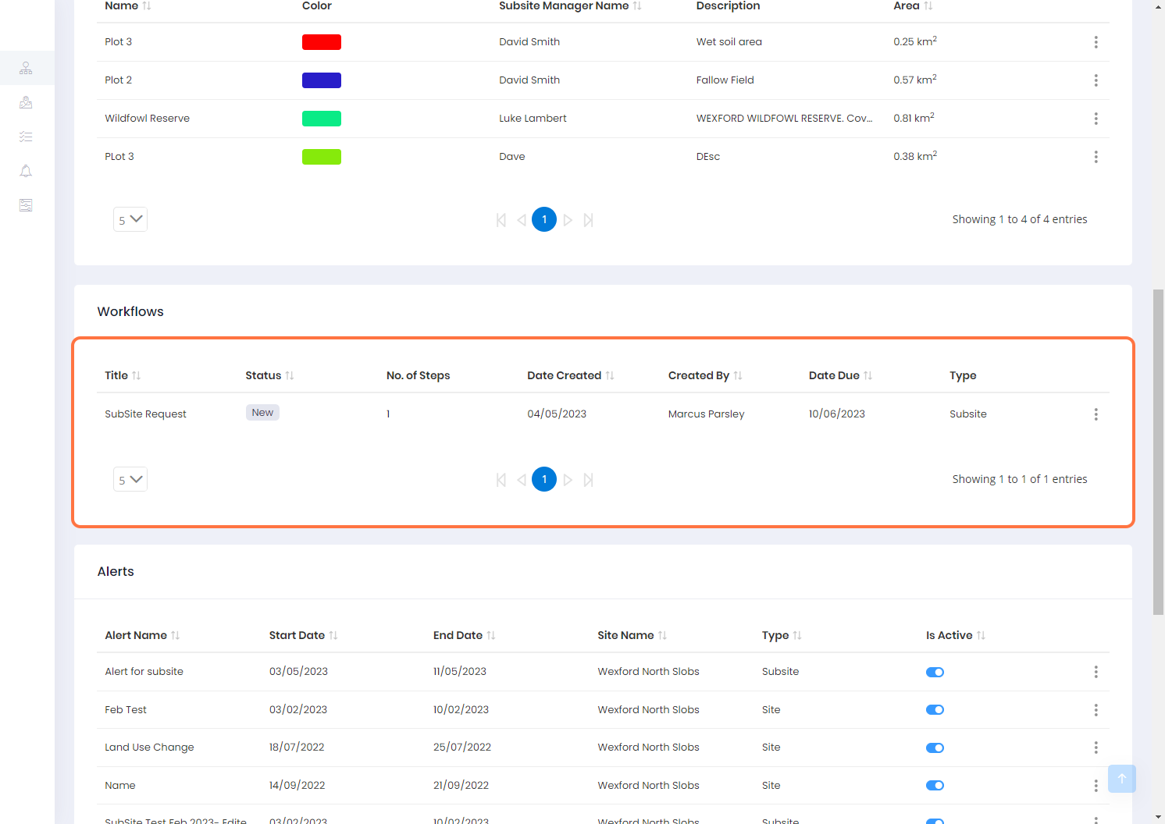

9 - Site Details Overview (5/7)

A list of associated alerts can be viewed here.

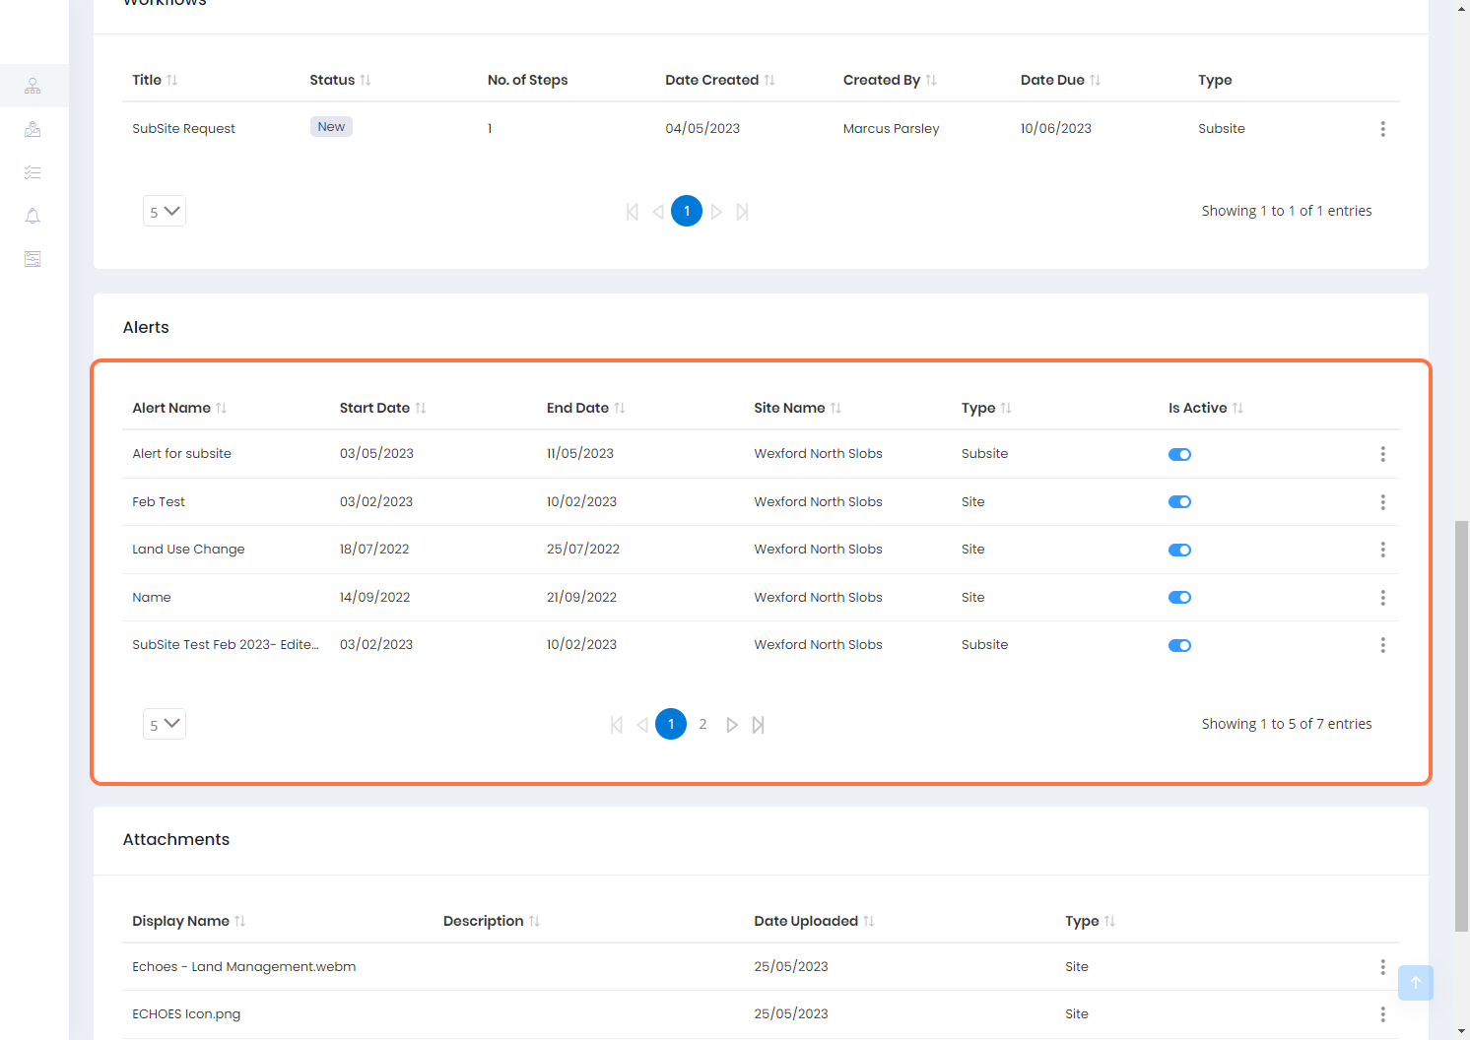

10 - Site Details Overview (6/7)

A list of any attachments associated to this site can be viewed here.

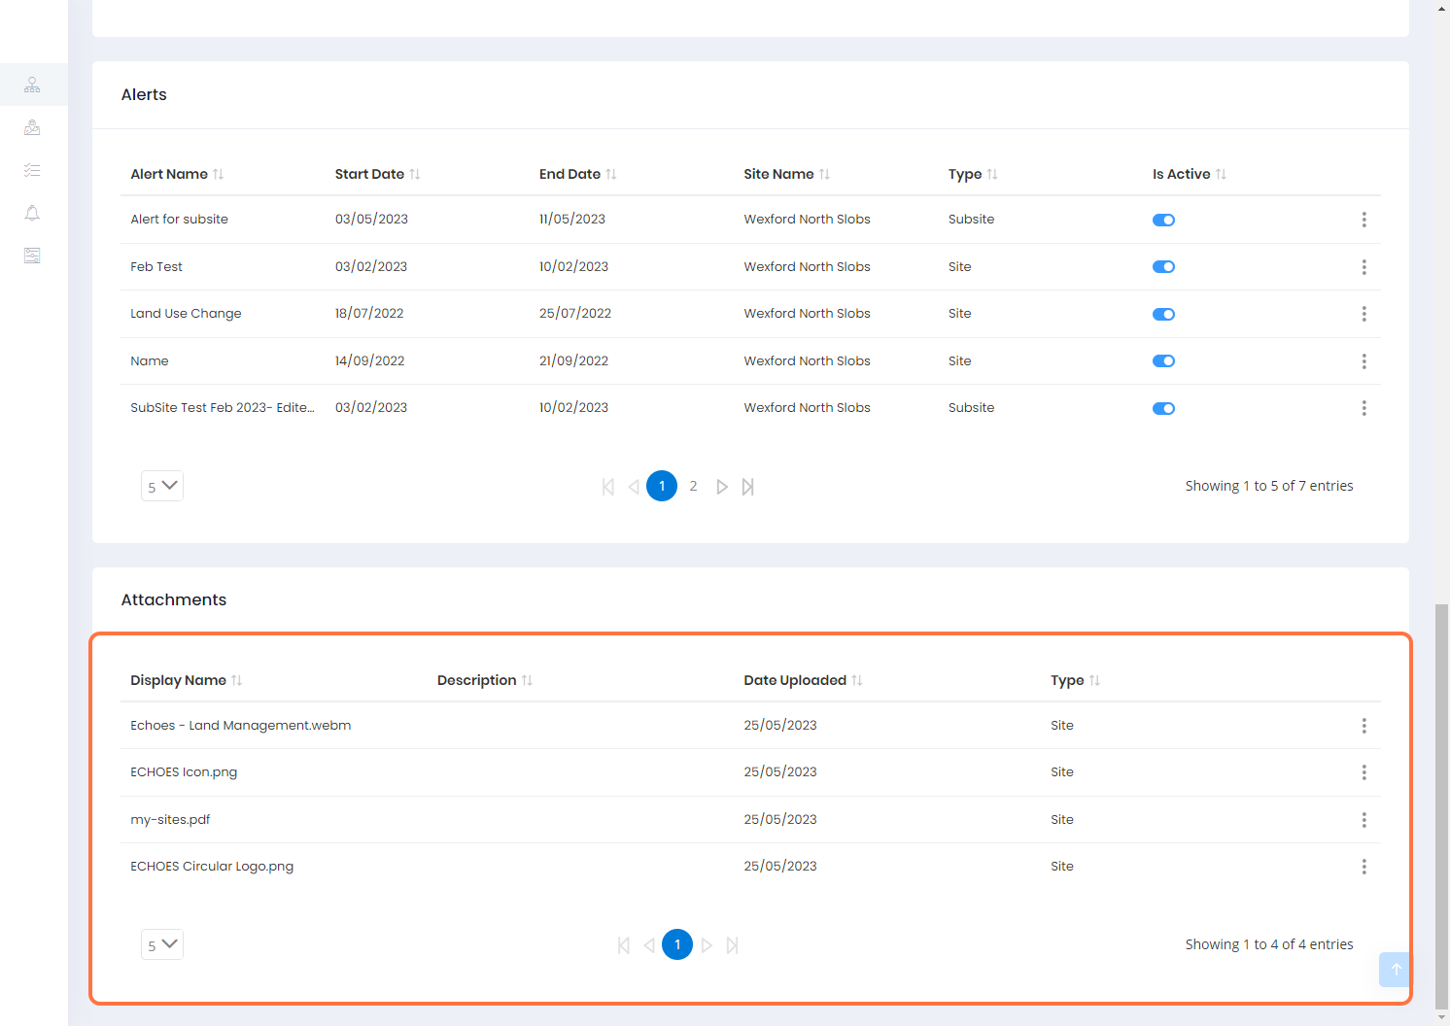

11 - Site Details Overview (7/7)

There is a more visual way to see and add attachments to the site by clicking the attachments button, which is within the site details section, as shown below. You can find more detail about the attachment's component in the ‘How to Upload an Attachment’ document.

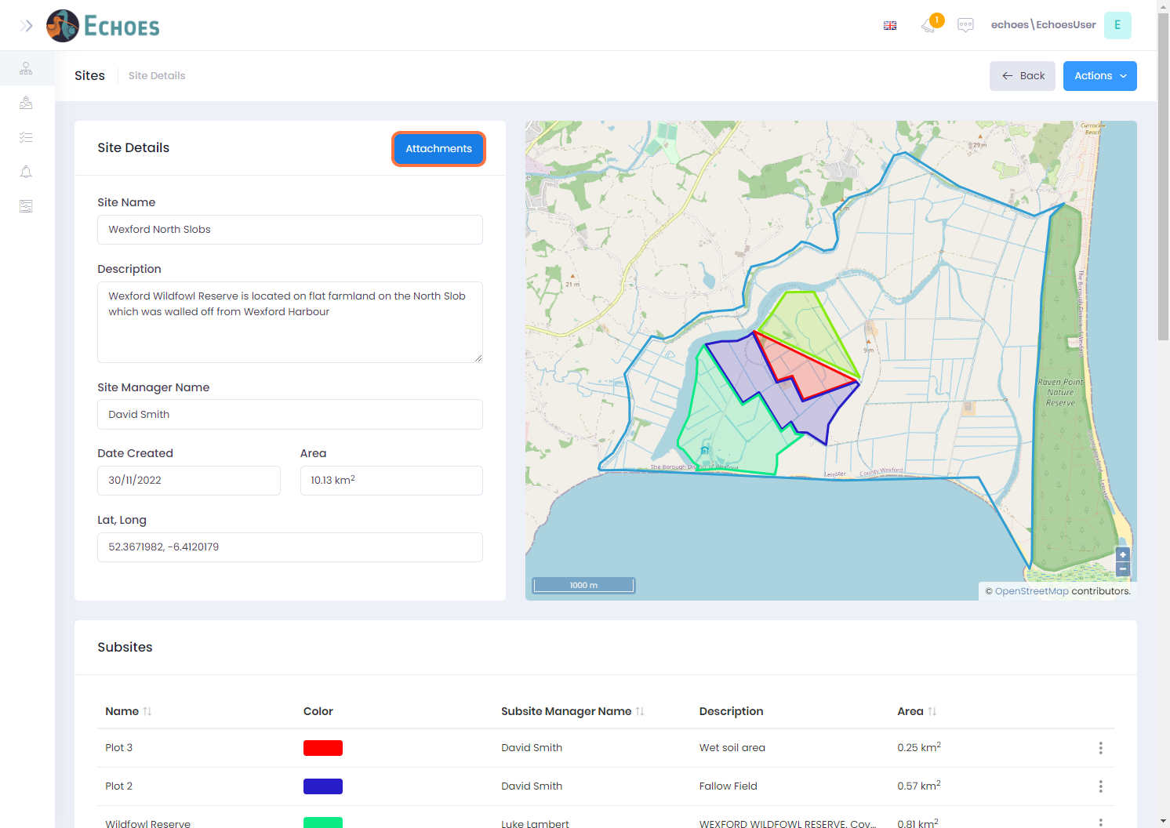

12 - Editing a Site (1/2)

* From within the sites details section, you can click the Actions button, then choose the 'Edit Site' option.

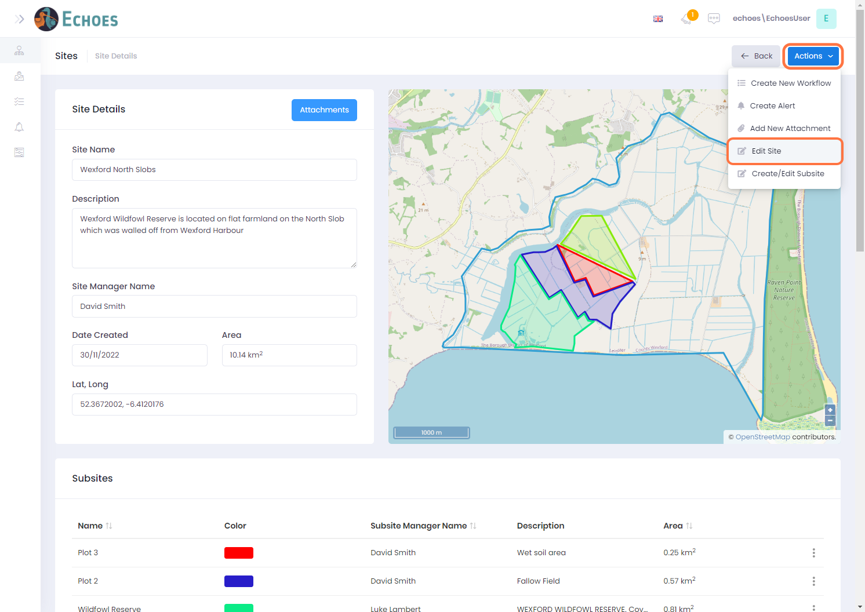

13 - Editing a Site (1/2)

* Back from the my sites page you can choose the site you want, then click the ellipses icon and choose the 'Edit' option which will open the sites details in the edit mode, the same as the option above would.

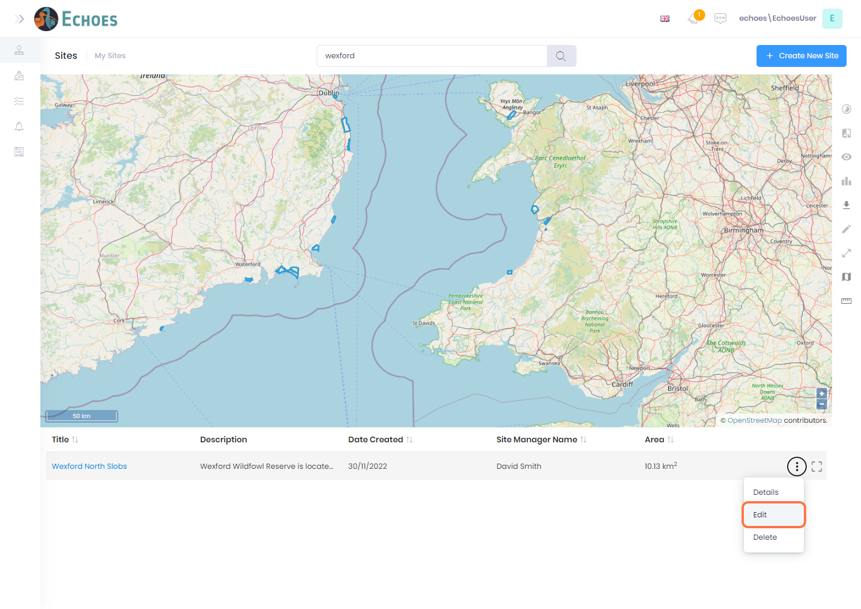

14 - Editing Site details information

Once the edit site option is opened, you can change the Site name, Description or the Site Managers name by clicking within the relevant text field.

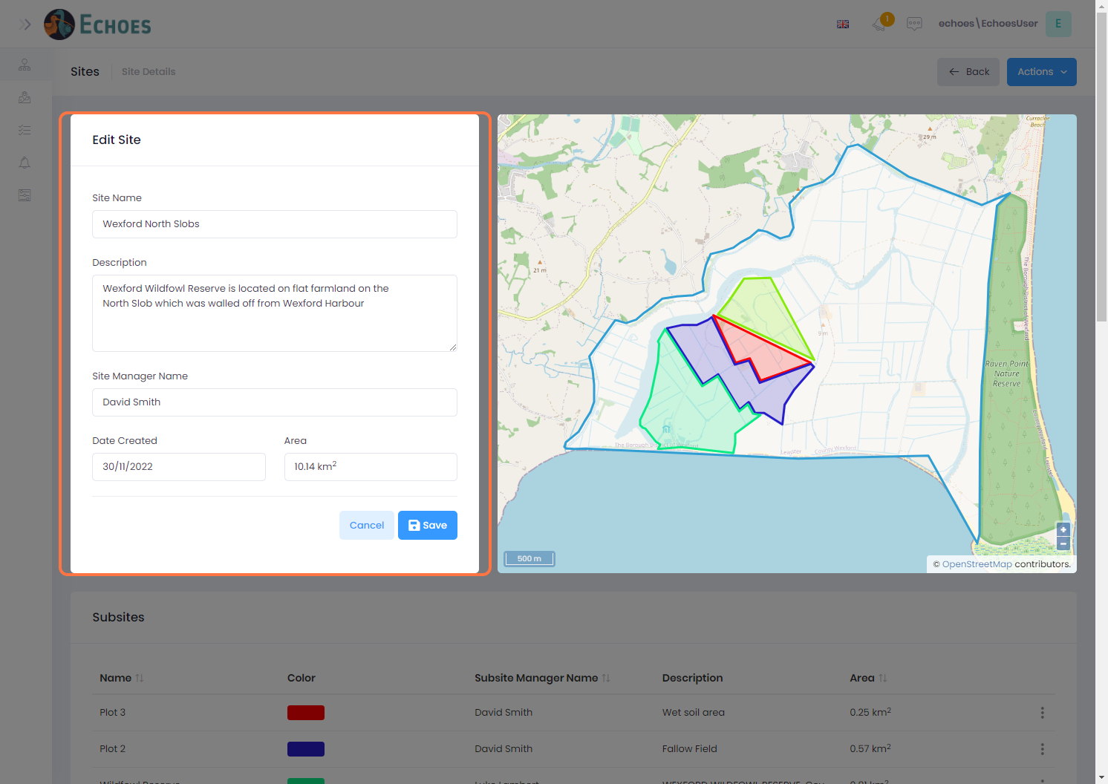

15 - Modify the boundary of your site

You can also modify the boundary of your site by clicking and dragging anywhere along the outline of your site.

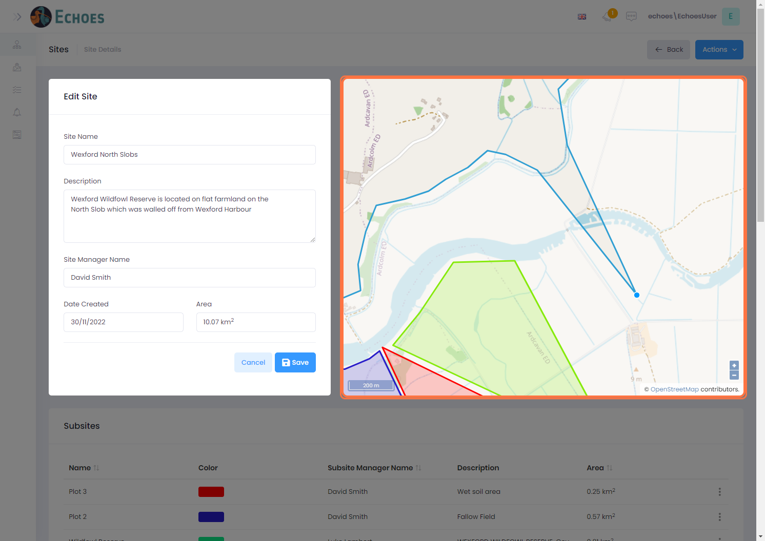

16 - Saving your edits

Once you are happy with your changes, click on the 'Save' button to save your changes

